Shrove Tuesday High Tea

One the last day before lent, known as Shrove Tuesday, it is customary to eat well before the great fast begins. The Catechists from the parish hosted a Shrove Tuesday High Tea on Tuesday 9 February in the Community Centre.
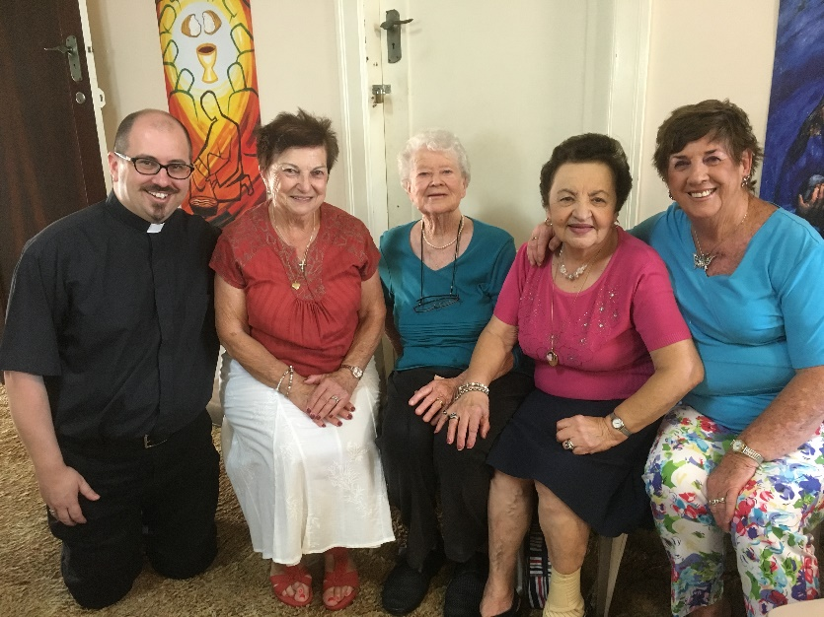
Many thanks for the time to enjoy sweet food and good company.
