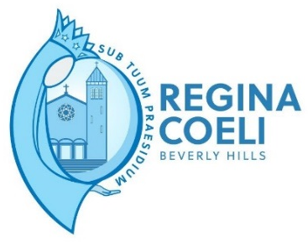

WEDDING BOOKING FORM
Name of priest conducting the wedding:
______________________________________
PO Box 100
2 Yarallah Place
Beverly Hills NSW 2209
paul.smithers@sydneycatholic.org

DATE OF MARRIAGE: ………………………….......................… TIME: ………………………...
BRIDEGROOM
BRIDE
Surname
Given names
Usual occupation
Usual place of residence
(full address)
Email
Phone contacts
Conjugal status
(for example, never validly married widower, widow, divorced)
Birthplace Date and Place of Birth
Religion (if Catholic please specify Rite as Roman, Melkite, Maronite
Date & Parish of Baptism
If born outside Australia
total period of residence in Australia
Father’s name in full
(f not known, write ‘unknown’
If deceased, add deceased’)
Mother’s maiden name in full
(f not known, write ‘unknown’
If deceased, add deceased’
Father’s country of birth
(if not known, insert ‘unknown’)
Mother’s country of birth
(if not known, insert ‘unknown’)

Please Circle: Nuptial Mass / Marriage Liturgy

Please note Marriages – SATURDAYS by appointment
Notice of 6 months is required. Please be advised to avoid disappointment it is recommended that you call the parish office on 9554 8155 before making your reception bookings.
.

DATE OF MARRIAGE: ………………………….......................… TIME: ………………………...

Once the booking fee payment of $800 is made to Regina Coeli Church Office, the date of your wedding will be secured. I understand that this is refundable should I advise of any cancellation outside of two months of the wedding.
Account Name: Beverly Hills Parish Church Account
Bank: CBA
BSB: 062784
Account Number: 11125001
Description: (name of Wedding and date)

It is customary to also offer a donation to the priest (A suggested amount is $450).

Signed: ……………………………………………….. Date: ………………………………………………..

To assist us with setting up the church for your ceremony could you please inform us of:

Number of Groomsmen: ………....... Number of Bridesmaids: ……………..

